E-Commerce Application - SOEN 341 Section SA

Minutes Meeting - Sprint 2.3 02/16/2022

horizontal line

**16 FEBRUARY 2022 / 1:00 PM / DISCORD**

# ATTENDEES

William Tremblay, Leon Zhang, Harrison Zhang, Alan Matthew Vadlakunta, Alice Chen, Emily Dang

# AGENDA

## **Last Meeting Follow-up**

1. Check-in for last meeting’s tasks
2. Presentation & Discussion of the website

## **Decisions**

* Finish first 3 tasks of Sprint 2 by Wednesday 9th February (rewrite the user stories with the right format, break down user stories into tasks, allocate story points to user stories)

NOTES

* Presentation on back-end, Express and database, mysql

# ACTION ITEMS

1. Assign task to project

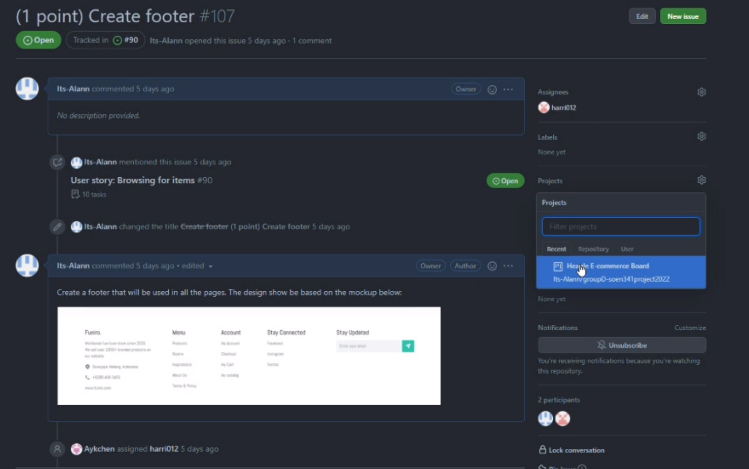

1. Complete tasks from user story 1 by friday, february 18th

# NEXT WEEK’S AGENDA

Next meeting: **Saturday February 19th**